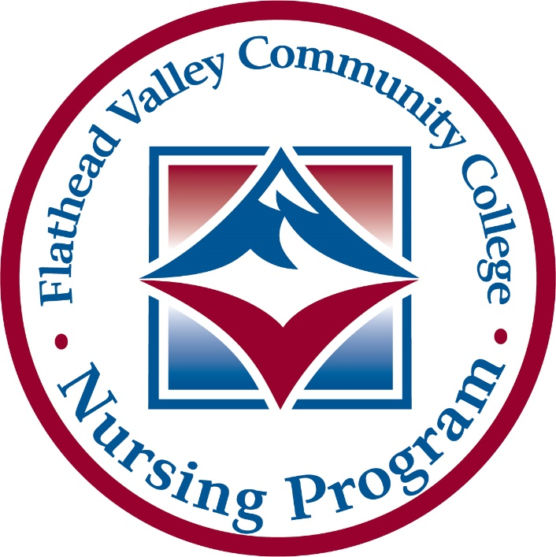

Page 1 of 8

**Certified Nursing Assistant (CNA)**

Registration Packet

www.fvcc.edu/cna

Page 2 of 8

REVISED 12/2024

CNA Course Registration Instructions

**CNA Course Registration Instructions**

**Registration will be on a first-come, first-served basis for those who have all documentation completed. A completed packet does not guarantee enrollment in NRSG 106.**

1. Apply for Admission to FVCC online at <https://www.fvcc.edu/student-admissions/apply-for-admission/> If a student is not able to apply online they may complete a paper application for admission in the FVCC’s Admissions Office in Blake Hall.
2. Follow the link in this packet to complete your background check through CastleBranch. Under “Please Select”, Select the C.N.A. option from the dropdown menu.
3. Complete the required immunizations and blood tests from the list provided in this packet. Then upload the immunization documents to the CastleBranch website following the instructions on their website (website link provided in this packet). It can take a few weeks to get the results of titers (blood tests). Please plan accordingly and don’t wait until the last minute to have these tests done.
4. After your background check is completed and all required immunizations and blood test results are uploaded in CastleBranch, contact the C.N.A. Coordinator or Program Assistant to register for this course.

If you complete the requirements and are not able to enroll in the course, you will be all ready to go for the next semester or to fill a vacancy if another student has to drop the course before it starts.

**Decisions to cancel courses due to low enrollment are made 3-4 weeks before the start each semester. Potential students should plan to complete the registration process 4 weeks prior to the start of each semester. Students may continue to register for CNA courses if the course has not been cancelled due to low enrollment.**

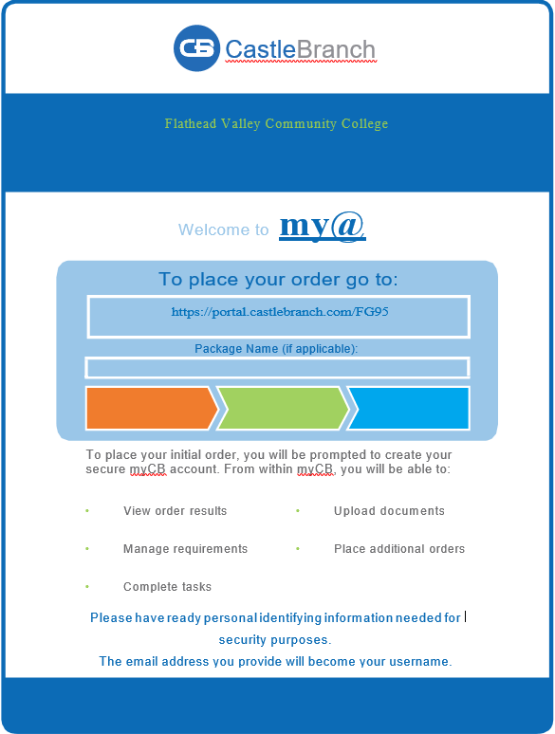

Website to complete background check and upload required immunizations

Page 3 of 8

**Please read all instructions carefully.**

If you have questions about these requirements, please contact the FVCC Nursing Office located in room BC 102 inside the Rebecca Chaney Broussard Center for Nursing and Health Science, or call (406) 756-3385 or (406) 756-3625.

Clinical facilities require background checks and immunizations for security and patient safety purposes on individuals who provide services within the facility and especially those who supervise care and render treatment. Immunizations and screening required by clinical sites are based on Center for Disease Control (CDC) guidelines and state and federal law.

* Clinical rotations are an essential element in the C.N.A. course. Students who cannot participate in clinical rotation due to discrepancies revealed in a background check are unable to fulfill the requirements of the course.
* Students who do not provide all immunization and titer documents may be denied clinical access. If denied clinical access they will not be able to fulfill course requirements.
* This decision is made solely by the healthcare facility partner and not Flathead Valley Community College.
* To complete these requirements, students create a CastleBranch account that will prompt them through each step. The CastleBranch fee is $99.98 and is the responsibility of the applicant.
* **Discrepancies may result in students being denied final acceptance into the course.**

**Required Immunizations and Blood Tests *All immunization and titer documents must include the students name and date of birth and provider or facility doing the testing or immunizations.***

Required immunizations and screenings include:

* 2 MMR vaccines or positive titers for all 3 components
* Record of negative TB screening. This can be 2 step skin test, Quantiferon titer, or T-spot or negative chest xray completed in the past 12 months. *Students with a positive test must provide written clearance from their health care provider to participate in patient care.*
* *If it will be more than a year since the last TB test by the time clinical starts you may need an additional test to be eligible for clinical. If you have questions about your TB test status, please check with CNA Coordinator or Program Assistant.*
* Other vaccines may become **required** by clinical partners throughout the course. Individuals have the right to decline a vaccine. Individuals that decline immunizations, may be asked by a clinical site to sign a declination statement and/or wear a mask while at the clinical site. Students who decline immunizations may be denied clinical access by a site, which could result in the student not being able to meet the objectives for the clinical portion of the course and thus not being able to pass the course.

Page 4 of 8

Immunization and Titers Requirements

The vaccinations listed below are **recommended,** both for student and patient protection, but not required. Students may be asked about vaccine status by clinical sites.

* ***Tdap****:* Proof of immunization as an adult per CDC guidelines.
* ***Hepatitis B Vaccination*:** Series of three injections with antibody titer demonstrating immunity. (anti-HBs).
* ***Varicella:*** Proof of chicken pox immunity by official record of vaccination dates, or lab titer demonstrating immunity.
* ***Influenza and Covid-19 Vaccine:***Booster recommended annually.

*If it will be more than a year since the last TB test by the time clinical starts you may need an additional test to be eligible for clinical. If you have questions about your TB test status, please check with CNA Coordinator or Program Assistant.*

Page 5 of 8

**CNA Course Frequently Asked Questions**

**Can I be a non-degree seeking student and take the CNA course?**

Yes

**Is placement testing required for this course?**

A placement test is not required for this course

**Where can I find the schedule of CNA classes?** Course schedules can be viewed at <https://www.fvcc.edu/academics/academic-resources/course-schedules?highlight=course+schedules>. The course number is NRSG 106.

**How will the FVCC Nursing Office know the results of my background check?**

The FVCC Nursing Office will receive a report from the background check agency. The applicant should receive an email from the background check agency when the report has been completed.

**Can I register for the course if the titer (blood tests) have been administered, but the test results are not available?**

No. The applicant needs to have the results. The reason for having the blood tested is to be sure the applicant has immunity to these diseases and is free of tuberculosis. If the applicant is not immune, further shots may be required before being allowed to enroll in the course.

**Where is the FVCC Nursing Office located?**

The Rebecca Chaney Broussard Center for Nursing and Health Science, room 102

**If I have had misdemeanor or felony charges in the past, can I register for the course?**

Discrepancies on a background check will be reviewed on a case-by-case basis by the hosting facility.

**How long is the CNA course?**

The course consists of 105 hours of training. The course may be scheduled in a variety of configurations.

**What is the cost of the course?**

The cost of the course will vary depending on whether the student lives in district or out-of-district. The cost will include five credits of tuition plus associated fees. The applicant also will be responsible for covering the costs of the background check, immunizations, scrubs, watch with a sweeping second hand, textbook and shoes if needed. More information on cost of tuition and fees can be found on the FVCC website, [www.fvcc.edu/pay-for-college/tuition-fees/](http://www.fvcc.edu/pay-for-college/tuition-fees/) or from the FVCC Business Office in Blake Hall.

**CNA Course Frequently Asked Questions (cont’d)**

**How does a student become certified as a nursing assistant?**

At the end of the course, each student will take the Montana State Competency Skills and Written Exam. The fee for this exam is included in the lab fee. If the student does not pass on the first attempt, the student will have to make arrangements to schedule and pay for addition testing. The student may test a maximum of three times (paying the testing fees each time they test.) If for some reason the student does not pass the exam in three attempts, the student will be required to take a state approved course before testing again.

**What is the age requirement for taking the CNA course?**

The minimum age to take the state certification exam is 16. Students who have not yet reached the age of 18 may have some employment restrictions. If you are not yet 18, please contact the CNA Coordinator for more information.

**If I cannot locate my immunization records, what is the next course of action?**

Applicants may be able to obtain a copy of their immunizations from the last school they attended. Some schools record immunizations on the students’ transcripts. The county health department may be able to obtain records of their previous immunizations depending on when and where the immunizations were given. Applicants also have the option of getting the required immunizations again, or they can have blood tests drawn to show if they are immune to the diseases for which immunizations are required.

**What if I complete all the requirements for registration, but the section of the course I want to register for is full or is cancelled due to low enrollment?**

Registration is completed on a first-come, first-served basis. If the section of the course the applicant desires to register for is full or if a section of the course is cancelled due to low enrollment,the applicant could choose to register for another section that is not full or could choose to wait to register for a future course. There are also occasions where a student has to drop the class right before the course begins. Applicants with completed documentation will have first priority to register for any last-minute vacancies in the course.

**How long are the immunizations valid?**

Many of the immunizations will be good throughout the applicant’s adult life, however boosters of some immunizations maybe required to meet current clinical site requirements and CDC guidelines. The TB test may need to be repeated annually depending on the health care facility’s regulations.

**What is a titer?**

A titer is a blood test to determine if a person has immunity to a disease such as Hepatitis B.

**CNA Course Frequently Asked Questions (cont’d)**

**What does the two-step Tuberculosis (TB) test involve?**

A small injection is administered under the skin. After 48 to 72 hours, the agency that administered the injection will read the test by looking at the appearance of the injection site. One to three weeks later, another injection will be given, and the reviewing of the injection site will be repeated 48 to 72 hours later.

**What if I have had the BCG vaccine in the past?**

An applicant who knows of having this vaccine should check with his/her health care provider to see which of the followingoptions, including a chest x-ray, an interferon test, or a T-Spot test would be most appropriate for the applicant.

**Can I become a CNA without taking this course?**

An individual can challenge the state skills competency and written exam to become a CNA. This process is not recommended for individuals who have never taken a training course. The individual challenging the exam will be responsible for knowing and understanding all information covered in a training program. The individual will need to find a facility that is willing to hire him/her without a completed State Competency Skills checklist. That facility will then have to have its staff observe and sign off all of the skills on the competency checklist. Individuals wishing to challenge the state competency exam can contact Headmaster at 1-800-393-8664. FVCC does not provide challenge testing. If the individual does not pass the challenge exam on the first attempt, including both the written and skills portions, that individual will be required to complete a state-approved nurse aide training program before testing again.

**Is there a required book for this course?**

Yes. “*Lippincott CoursePoint for Carter: Lippincott Textbook for Nursing Assistants: A Humanistic Approach to Caregiving, Sixth Edition”*. This digital resource is available in the FVCC Bookstore located in Blake Hall.

**When would I need to complete payment for the course?**

The student must complete payment or show proof of third party payment or financial aid before they can take the state exam. Payment plans can be made with the FVCC Business Office in Blake Hall. Proof of payment will need to be brought to the FVCC Nursing Office or to the instructor before the scheduled date of the state exam.

REVISED 5/2024

CNA Course FAQ

Page 6 of 8

REVISED 12/2024

REVISED 12/2024

Page 7 of 8

Page 8 of 8

REVISED 12/2024

REVISED 10/05/ 2018